MATHEMATICS SPECIALIST

MAWA Year 12 Examination 2018

Calculator-assumed

Marking Key

© MAWA, 2018
Licence Agreement
This examination is Copyright but may be freely used within the school that purchases this licence.
- The items that are contained in this examination are to be used solely in the school for which they are purchased.
- They are not to be shared in any manner with a school which has not purchased their own licence.
- The items and the solutions/marking keys are to be kept confidentially and not copied or made available to anyone who is not a teacher at the school. Teachers may give feedback to students in the form of showing them how the work is marked but students are not to retain a copy of the paper or marking guide until the agreed release date stipulated in the purchasing agreement/licence.

The release date for this exam and marking scheme is
- the end of week 1 of term 4, 2018

Question 8 (5 marks)

Solution
Mathematical behaviours | Marks
- states the correct critical values  - writes correct equations for each sub-interval  - determines correct conclusion for  - correct solution for  - provides the correct solution for | 1  1  1  1  1

Question 9 (a) (3 marks)
Solution
If
then
Mathematical behaviours | Marks
- combines the two fractions  - inverts the expression and multiplies by the complex conjugate  - deduces the correct real and imaginary parts | 1  1  1

Question 9(b) (1 mark)

Solution
From calculator
Mathematical behaviours | Marks
- states the value required quoting the answer to eight places | 1

Question 9(c) (1 mark)

Solution
Since if and .
The smallest possible solution is clearly .
Mathematical behaviours | Marks
- solves for the required giving the answer in radians | 1

Question 9(d) (1 mark)

Solution
From (b) we deduce that .

Mathematical behaviours | Marks
- combines the results of parts (a) and (b) to infer the exact value | 1

Question 10(a) (2 marks)
Solution
Given that is a solution of
then

Real parts give that
and imaginary parts imply that
Mathematical behaviours | Marks
- substitutes the value into the equation  - deduces the required values of and | 1  1

Question 10(b) (4 marks)
Solution
Since is a solution of the polynomial equation then so is
Hence the quartic has a factor
By long division

By the quadratic formula the equation has solutions
Hence the required three other solutions are and

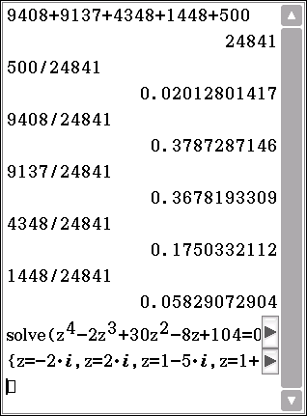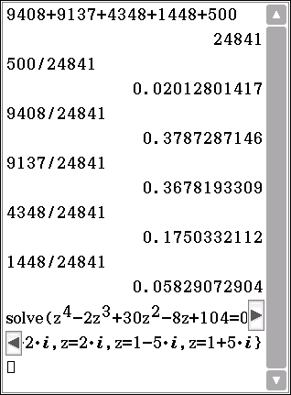

Mathematical behaviours | Marks
- correctly notes that the conjugate is also a solution  - notes that the quartic has a factor  - factorises the quartic  - deduces the required extra solutions of the quartic | 1  1  1  1

Question 11(a) (1 mark)
Solution
$$a=\left(2i+3j+2k\right)×\left(3i+5j+k\right)$$
$=\left(3×1-2×5\right)i+\left(2×3-1×2\right)j+\left(2×5-3×3\right)k$ $=-7i+4j+k$
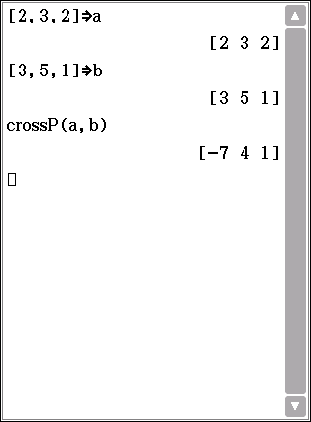
Mathematical behaviours | Marks
- evaluates the cross product correctly | 1

Question 11(b) (2 marks)
Solution
$2i+3j+2k$ and 3$i+5j+k$ are normal to the planes $P_{1}$ and $P_{2}$
and $a$ is perpendicular to both of these normals. (*)
So $a$ is parallel to vectors in each of the planes $P_{1}$ and $P_{2}$
So $a$ is parallel to the line of intersection of these planes, i.e. L. (**)
Mathematical behaviours | Marks
- obtains result (*)  - completes the argument correctly (**) | 1  1

Question 11(c) (2 marks)
Solution
Since $a$ is parallel to L, a vector equation for L has the form $r=xi+yj+zk=r_{0}+ta$

As $\left(0,1,0\right)$ lies in L, we may assume that $r_{0}=j$

So $r=xi+yj+zk=j+t(-7i+4j+k)$ is a vector equation for L.
Mathematical behaviours | Marks
- evaluates $r_{0}$  - obtains a correct vector form of equation | 1  1

Question 11(d)(i) (3 marks)
Solution
The equations $\begin{matrix}2x+3y+2z=3 \\ 3x+5y+z=5 \\ 7x+11y+az=b\end{matrix}$ reduce to $\begin{matrix}x+7z=0 \\ y-4z=1 \\ \left(a-5\right)z=b-11\end{matrix}$ (*)

The planes $P_{1}$, $P_{2}$ and $P_{3}$have infinitely points in common if the third equation reduces to $0×z=0$, i.e. if $a=5$ and $b=11$

Mathematical behaviours | Marks
- attempts simultaneous reduction of the equations for $P_{1}$, $P_{2}$ and $P_{3}$  - derives equation (*)  - deduces the correct solutions | 1  1  1

Question 11(d)(ii) (1 mark)
Solution
The planes $P_{1}$, $P_{2}$ and $P_{3}$have no point in common if equations (*) in d(i) are inconsistent,
i.e. the third equation reduces to $0×z≠0$, i.e. if $a=5$ and $b≠11.$
Mathematical behaviours | Marks
- deduces the correct solution | 1

Question 12 (a) (2 marks)

Solution
Mathematical behaviours | Marks
- derives correct expression for  - derives correct expression for | 1  1

Question 12 (b) (2 marks)

Solution
Mathematical behaviours | Marks
- states correct domain  - states correct range | 1  1

Question 12 (c) (3 marks)

Solution
Mathematical behaviours | Marks
- states correct domain including mention of the  - states correct range | 1+1  1

Question 13(a) (3 marks)
Solution
For the curve lies above the line so
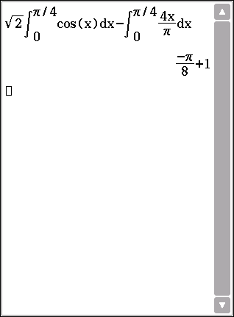
Mathematical behaviours | Marks
- gives a sketch of the form of the area  - writes down the correct expression for the required area  - evaluates the two integrals to deduce the necessary result | 1  1  1

Question 13(b) (2 marks)
Solution
Required volume of rotation is given by

Mathematical behaviours | Marks
- writes down the appropriate expression for the volume for the two parts  - deduces the correct volume | 1  1

Question 14 (a) (2 marks)

Solution
Since , then motion is SHM with period = .
Mathematical behaviours | Marks
- differentiates to obtain experession for acceleration  - shows motion is simple harmonic with correct period | 1  1

Question 14 (b) (2 marks)

Solution
Mathematical behaviours | Marks
- states correct amplitude  - states correct displacement equation | 1  1

Question 14 (c) (2 marks)

Solution
Mathematical behaviours | Marks
- states correct maximum speed  - states correct minimum speed | 1  1

Question 14 (d) (3 marks)

Solution
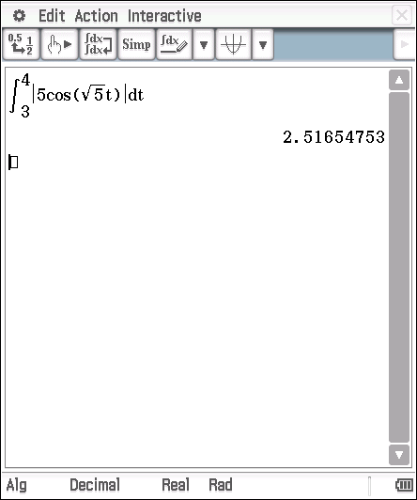
Mathematical behaviours | Marks
- expresses velocity as a function of time  - integrates using correct upper and lower values  - calculates distance travelled | 1  1  1

Question 14 (e) (2 marks)

Solution
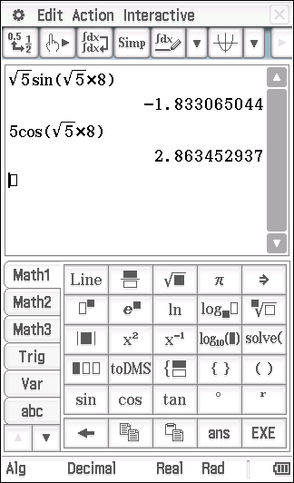
Mathematical behaviours | Marks
- calculates and  - draws correct conclusion | 1  1

Question 15 (4 marks)
Solution
If we write
Equating the coefficients gives and

Hence
Mathematical behaviours | Marks
- writes down the appropriate form of the partial fractions  - compares coefficients to deduce the constants and  - integrates correctly  - deduces the required result | 1  1  1  1

Question 16 (a) (1 mark)
Solution
The parabola joins the orgin with the point (9,6)
Line cuts parabola within the domain if .
Mathematical behaviours | Marks
- determines correctly the required inequality | 1

Question 16 (b) (3 marks)
Solution
There is no need to compute the point of intersection. The two areas are equal if the area under the parabola over matches the area under the line.

Now
and
Thus
Mathematical behaviours | Marks
- realises there is no need to determine the point of intersection  - evaluates the areas under the line and parabola over  - deduces the requisite value of | 1  1  1

Question 17(a) (2 marks)
Solution
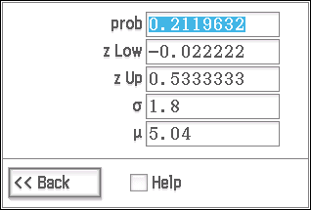
$P\left(5<X<6\right)=P\left(\frac{5-5.04}{1.8}<\frac{X-5.04}{1.8}<\frac{6-5.04}{1.8}\right)$
$=P\left(-0.02<Z<0.53\right)$ (*)
$=0.702-0.492=0.21$
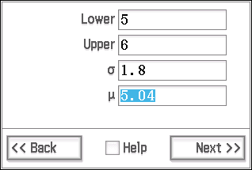
Mathematical behaviours | Marks
- derives the correct Z-limits  - obtains the correct answer | 1  1

Question 17(b) (2 marks)
Solution
From the calculator (or tables) $P\left(Z<0.675\right)=0.75$
$$\frac{X-5.04}{1.8}=0.675⇒X=5.04+1.8×0.675=6.255$$
That is, the upper quartile of the distribution is 6.255
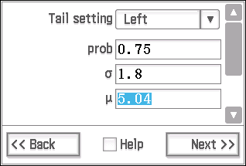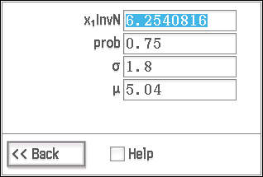

Mathematical behaviours | Marks
- calculates 0.675 as the upper quartile in the normal distribution  - obtains the correct answer | 1  1

Question 17(c) (2 marks)
Solution
From the formula sheet $E=z_{α}\frac{σ}{\sqrt{n}}$ (*)

Since $z_{0.95}=1.96$ , $E=0.2$ and $σ≅1.3$
$\sqrt{n}≅1.96×\frac{1.3}{0.2}=12.74$ and so $n≅162.3$
So the sample size needs to be at least 163
Mathematical behaviours | Marks
- uses the formula (*)  - obtains the correct answer | 1  1

Question 17(d) (2 marks)
Solution
$\overline{X}=4.55$, and $E=z_{α}\frac{s}{\sqrt{n}}=1.96×\frac{1.36}{\sqrt{200}}≅0.19$

So the 95% confidence interval is $4.55-0.19<μ_{acu}<4.55+0.19$

i.e. 4$.36<μ_{acu}<4.74$
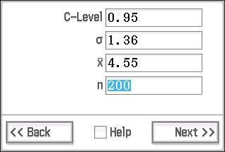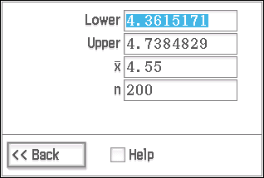
Mathematical behaviours | Marks
- evaluates E correctly  - dervies the correct limits for the confidence interval | 1  1

Question 17(e) (2 marks)
Solution
The statement is correct.

This is because 5.04, the mean number of migraine attacks for untreated people, is much greater than 4.74, the upper limit of the upper limit of the 95% confidence interval for $μ_{acu},$ the average number of migraine attacks for people given acupuncture.
Mathematical behaviours | Marks
- accepts the claim  - gives a valid reason based on the confidence interval | 1  1

Question 17(f) (5 marks)
Solution
We determine a 95% confidence interval for $μ_{drug},$ the average number of migraine attacks for people who take the drug.

$\overline{X}=4.18$, and $E=z_{α}\frac{s}{\sqrt{n}}=1.96×\frac{2.43}{\sqrt{100}}≅0.48$
So the 95% confidence interval is $4.18-0.48<μ_{drug}<4.18+0.48$
i.e. $3.70<μ_{drug}<4.66$
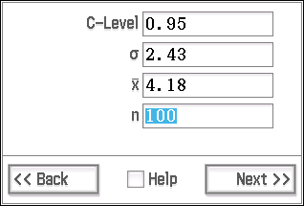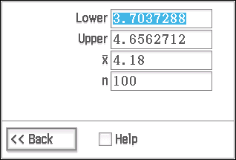

These tests DO NOT clearly show that the drug is more effective than acupuncture in treating migraine attacks, (*) because 4$.36<μ_{acu}<4.74$ and $3.70<μ_{drug}<4.66,$ the confidence intervals for $μ_{acu}$ and $μ_{drug},$ overlap considerably.
Mathematical behaviours | Marks
- constructs a confidence interval for $μ_{drug}$  - sets the confidence level at least as high as 90%  - obtains correct limits for the confidence interval for $μ_{drug}$  - obtains the correct conclusion about the tests (*)  - gives a valid reason in terms of overlapping confidence intervals | 1  1  1  1  1

Question 18(a) (4 marks)
Solution
$$v_{1}\left(t\right)=v_{0}\left(t\right)+at=40i+20j+\left(80-8t\right)k$$
and $r_{1}\left(t\right)=\int_{0}^{t}{v_{1}\left(u\right)du=}40ti+20tj+\left(80t-4t^{2}\right)k$, (*) because $r_{1}\left(0\right)=0$
$80t-4t^{2}=0$ when $t=0$ or $t=20.$
So rocket A returns to the horizontal plane H when $t=20.$
$r_{1}\left(20\right)=\int_{0}^{t}{v_{1}\left(u\right)du=}800i+400j$,
and the distance of this point from O is $\sqrt{{800}^{2}+{400}^{2}}≅894 m$

Mathematical behaviours | Marks
- obtains expression for $v_{1}\left(t\right)$ (*)  - obtains expression for $r_{1}\left(t\right)$ (*)  - solves for t  - obtains the correct answer | 1  1  1  1

Question 18(b) (3 marks)
Solution
Since $v_{2}$ is constant, $r_{2}\left(t\right)=r_{2}\left(0\right)+tv_{2}=600i+vt\cos{θj+vt\sin{θ}k}$ (*)

If the flight paths meet, $r_{1}\left(t\right)=r_{2}\left(t'\right)$ for some values of $t$ and $t^{'}.$

So $40t=600,$ $t=15$ and $r_{1}\left(15\right)=600i+300j+300k$ (**)

If $r_{2}\left(t'\right)=600i+300j+300k,$ $vt'\cos{θ=300}$and $vt'\sin{θ=300.}$

So $\cos{θ=\sin{θ}}$and hence $θ=45°$.
Mathematical behaviours | Marks
- solves for $r_{2}\left(t\right)$ (*)  - locates points where the flight paths meet  - obtains correct answer for $θ$ | 1  1  1

Question 18(c) (2 marks)
Solution
From part (b), if the rockets collide $r_{2}\left(15\right)=600i+300j+300k$ (*)
Also from (b), $t=15,$ and $θ=45°$ so that $15v\cos{θ}=300$ implying that $v=20\sqrt{2}≅28.3$
So the speed of rocket B is $28 ms^{-1}$ (approximately) if the rockets collide.
Mathematical behaviours | Marks
- uses $r_{2}\left(15\right)=r_{1}\left(15\right)$ (*)  - obtains correct answer | 1  1

Question 19 (7 marks)
Solution
If the cross section of the sphere is given by then the volume of water is given
by

Now the volume of the complete sphere is
so the computed volume is a fraction
When we put
the fraction reduces to ½ as anticipated as this denotes the sphere is half full.
When
the fraction equals 1 corresponding to a completely full sphere
Mathematical behaviours | Marks
- writes down an appropriate integral…..  - …with the correct limits  - integrates correctly and inserts the limits  - simplifies the expression  - evaluates the correct fraction of the complete volume  - interprets correctly the case when  - interprets correctly the case when | 1  1  1  1  1  1  1

Question 20 (a) (3 marks)

Solution
Mathematical behaviours | Marks
- rewrites integral in terms of  - determines correct antiderivative  - rewrites antiderivative in terms of | 1  1  1

Question 20(b) (2 marks)

Solution
Mathematical behaviours | Marks
- differentiates implicitly to determine  - establishes | 1  1

Question 20 (c) (2 marks)

Solution
Mathematical behaviours | Marks
- differentiates implicitly to determine  - establishes | 1  1

Question 20 (d) (5 marks)
Solution

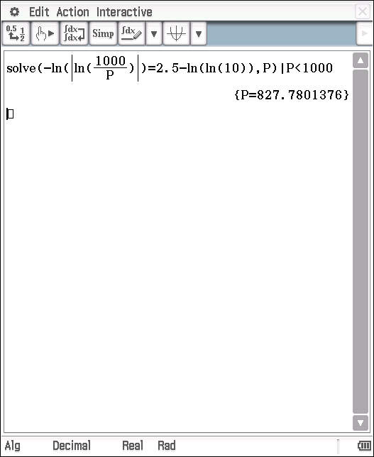

The second model predicts a slightly smaller population.
Mathematical behaviours | Marks
- correct population equation using logistic equation  - calculates population size  - correct population equation using second model  - calculates population size  - compares predicted population sizes | 1  1  1  1  1

